Design Section 5: Rank Comparison
This section will compare the user’s average replay data to the average data of a specific rank. Spider charts will be used to do this by request of Adam from Interview 3.
5.1 Data compared
The data that will be compared will be mostly the same as the Data Overview section, since both sections aim to compare the user’s replay data to other players, the difference being that this section compares the user’s average to the average of an entire rank, rather than directly to other players in the replay.
Boost
- Boost Usage
- Wasted Usage
- Number of small boosts
- Number of large boosts
- Time spent on no boost
- Time spent on low boost
- Time spent on full boost
Movement
- Average speed
- Time spent supersonic speed (maximum speed)
- Time spent on the ground
- Time spent low in the air
- Time spent high in the air
Positioning
- Time spent as most back player
- Time spent between players
- Time spent as most forward player
- Time spent closest to ball
- Time spent farthest from ball
- Time spent behind the ball
- Time spent ahead of the ball
- Time spent in the defending third
- Time spent in the neutral third
- Time spent in the attacking third
Demos / Aggression / Possession
- Number of demolitions inflicted
- Number of demolitions taken
- Number of big boost pads stolen
- Time spent with possession
- Average duration of possession
Justification for each statistic is included in Design Section 3 Data Overview. The final Spider chart combines 2 categories simply to give the spider chart enough vertices, since spider charts with less than 5 vertices look awkward. With all significant statistics, as well as others, covered, Requirement 2.1.9 will be met upon implementation.
5.2 Example spider chart
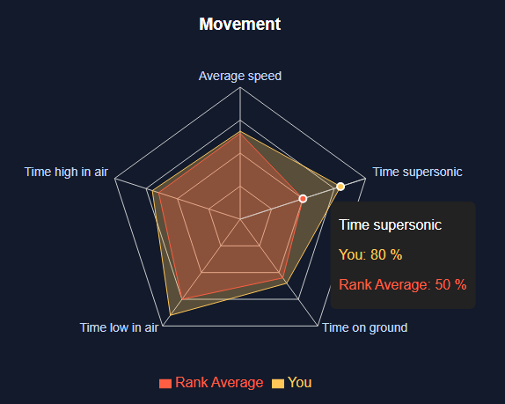
This chart shows a clear distinction between the user’s and the specified rank average, with a tooltip to display the exact values. Requirements 2.1.4-2.1.7 are met through the contrasting, consistent colours, and clear labelling. The spider chart itself shows a step toward meeting Requirement 1.4.4
The problem with this chart is that the domain of each axis ranges from 0 to 100, meaning that for statistics such as average speed, where a difference of only a few percent is significant, the significance between the difference is not accurately displayed. In the Implementation stage of the project, I will have the domain be custom with 2.5 standard deviations above and below the mean, which will represent approximately 98% of the data. In the case that the user’s data goes out of these bounds, then the user’s value will be used as the maximum/minimum of the domain.
5.3 Outliers
The aim of this part will be to meet Requirements 1.4.3 and 1.4.6, and so by highlighting the biggest differences, I can draw attention to statistics that the user should pay attention to and try to guide them to figure out why their data is so different to most, and potentially what to do about it.
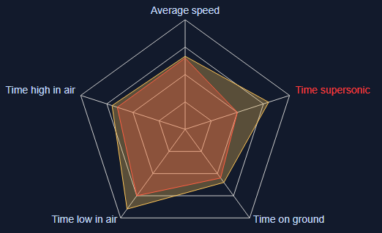
By highlighting the outlier statistic in a contrasting red, Requirement 2.1.10 is met.
As shown in Design Section 1: User Interface, below the spider charts there will be a list of outliers, which will be decided based on a roughly 1 standard deviation difference from the mean (bottom / top 15%), since this will show a significant enough difference between others to be worth taking notice to. Each of these outliers will be paired with a simple piece of advice and possible reasoning for such a high statistic, there will not be heavy focus on the advice in this section since the main purpose is to visualise the comparison, the list will just make it easier to make sense of the data that the user should be paying attention to.

